** Prayagraj- 211004**

**Report**

***ON***

**KNECT MOBILE ACCESSORIES STORE**

***By***

**HARSHIT KUMAR (Reg No:- 2018IS02)**

**NITISH KUMAR (Reg No:- 2018IS09)**

**DHARSHNAM RAKESH (Reg No:- 2018IS04)**

**Submitted to**

**The Department Of Computer Science & Engineering**

**Master of Technology (M.Tech)**



**UNDERTAKING**

We declare that the work presented in this report titled "KNECT MOBILE ACCESSORIES", submitted to the Computer Science and Engineering Department, Motilal Nehru National Institute of Technology Allahabad, Prayagraj. We have not plagiarized or submitted the same work for the award of any other project. In case this undertaking is found incorrect. We accept that our project may be unconditionally withdrawn.

April 28, 2019

Harshit Kumar (2018IS02)

Nitish Kumar (2018IS09)

Dharshnam Rakesh (2018IS04)



**CERTIFICATE**

Certified that the work contained in the report titled "KNECT MOBILE ACCESSORIES" has been carried out under my supervision and that this work has not been submitted elsewhere for a project.

**Project Member:- Dr. Manoj Madhava Gore**

Harshit Kumar (2018IS02) (Professor, CSED)

Nitish Kumar (2018IS09)

Dharshnam Rakesh (2018IS04)



**ACKNOWLEDGEMENT**

We wish to express my sincere gratitude to **Dr. Manoj Madhava Gore** for providing us an opportunity to work in this project and for his guidance and encouragement at every step of project.

He exposed us to the intricacies of relevant topics through proper counseling and discussions and always showed great interest in providing timely support and Suitable suggestions.

We would also like to thank other groups which willing to share information about study of android operating system and android application development. We would like to express our gratitude to all our friends in the Department of Computer Science for their constant support and encouragement.

**Contents**

**Preface: (Page No)**

**Acknowledgements …**………………… 4

**Chapter 1:**

* 1. Introduction …………………………………. 6

1.2 Objective ……………………………………. 7

1.3 Introduction various technologies used ……… 8

1.4 Project Overview ……………………………. 9

1.5 Various Modules of the project ……………… 10

**Chapter 2 (Design):**

2.1 ER. Diagram of this project ………………… 11

2.2 Information Flow Diagram …………………. 12

2.3 Site Map of this project ……………………. . 13

2.4 System Design ………………………………. 14

**Chapter 3:**

3.1 Implementations …….……………………… 15

3.2 Screenshots of Databases ………………….. 16-17

3.3 Screenshots of our project …………………. 17-18

3.4 Limitations ………………………………… 19

3.5 Future Scope ……………………………….. 20

**Chapter 4:**

4.1 Conclusion …………………………………. 21

**Chapter 5 (Appendices):**

5.1 Audits reports of FashionHUB project ……. 22

5.2 Efforts in hacking to spoil project ONDOOR**…** 23



**Introduction**

Online shopping is the process whereby consumers directly buy goods or services from a seller in real-time, without an intermediary service, over the Internet. It is a form of electronic commerce. This project is an attempt to provide the advantages of online shopping to customers of a real shop. It helps buying the products in the shop anywhere through internet by using desktop or Smartphone’s. Thus the customer will get the opportunity to choose and order the products online.

The Knect Mobile Accessories Store Management System project is a web based shopping system for an existing shop. It is developed for desktop systems to facilitate customers to view various mobile accessories, view their details and order them while sitting at home. It also facilitates admin (buyer) to view inventory, customer and order details. It can be used efficiently for physically separated shops in different locations. This website will provide in a simple and easy to operate user interface, which can be managed by any user without having prior in-depth knowledge of the computer system. One can use this website to get a sales report. Administrators can pull data, from any location from the server. This website is a complete package for small organizations which will allow them to keep track of their sales and inventory, and provide a computerized billing system.

**Objective**

* This Project aims at “Knect Mobile Accessories”, one step online solution for the people seeking mobile accessories.
* To provide a secure and user friendly platform where various users can get mobile accessories at a reasonable price.
* To ensure a proper management System with the help of a Admin Panel, who has control over the inventory, customers, orders, etc.
* To provide a client panel, so that clients may enter their details, view products, their details and can buy them at any time.
* To provide an interface through which admin can add/delete/view products through the admin panel.
* To design a one-step solution for customers, where they can find various products, read about their specifications and order the online mobile accessories.
* The beauty of project is the Interactive Environment, provided where a Client and Admin can easily interact with each other.
* To understand the technical knowledge behind the the e - commerce websites.
* It will help us to understand the security risks that e commerce websites may encounter.
* To work in a team and learn how a software works.

**Introduction Various Technologies used:**

**HTML:** Hypertext Markup Language (HTML) is the standard markup language for creating web pages and web applications. Web browsers receive HTML documents from a web server or from local storage and render the documents into multimedia web pages. HTML describes the structure of a web page semantically and originally included cues for the appearance of the document.

**CSS:** Cascading Style Sheets (CSS) is a simple mechanism for adding style (e.g., fonts, colors, spacing) to Web documents. These pages contain information on how to learn and use CSS and on available software.

**Bootstrap:** Bootstrap is a free and open-source CSS framework directed at responsive, mobile-first front-end web development. It contains CSS- and (optionally) JavaScript-based design templates for typography, forms, buttons, navigation and other interface components.

**JavaScript:** JavaScript is a prototype-based, multi-paradigm, dynamic language, supporting object-oriented, imperative, and declarative (e.g. functional programming) styles. As a multi-paradigm language, JavaScript supports event-driven, functional, and imperative (including object-oriented and prototype-based) programming styles. It has APIs for working with text, arrays, dates, regular expressions, and the DOM, but the language itself does not include any I/O, such as networking, storage, or graphics facilities. It relies upon the host environment in which it is embedded to provide these features.

**PHP:** Hypertext Pre-processor (or simply PHP) is a general-purpose programming language originally designed for web development. PHP code is usually processed by a PHP interpreter implemented as a module in a web server or as a Common Gateway Interface (CGI) executable. The web server combines the results of the interpreted and executed PHP code, which may be any type of data, including images, with the generated web page.

**XAMPP:** It is a free and open-source cross-platform web server solution stack package developed by Apache Friends, consisting mainly of the Apache HTTP Server, MySQL database, and interpreters for scripts written in the PHP and Perl programming languages. Since most actual web server deployments use the same components as XAMPP, it makes transitioning from a local test server to a live server possible.

**MySQL:** MySQL is an open-source relational database management system (RDBMS). Its name is a combination of “My", the name of co-founder Michael Widenius's daughter, and "SQL", the abbreviation for Structured Query Language. MySQL is a component of the XAMPP.

**Project Overview:**

The central concept of the web application is to allow the customer to shop virtually using the Internet and allow customers to buy the items and articles of their desire from the store. The information pertaining to the products are stores on an RDBMS at the server side (store).

The server process the customers and the items are shipped to the address submitted by them. The application is designed into two modules:

1. For the customers who wish to buy the articles.
2. For the administrator who maintains and updates the information pertaining to the mobile accessories and those of the customers.

The end user of this product is a departmental store where the application is hosted on the web and the administrator maintains the database. The application which is deployed at the customer database, the details of the items are brought forward from the database for the customer view based on the selection through the menu and the database of all the products are updated at the end of each transaction. Data entry into the application can be done through various screens designed for various levels of users. This website provide the most sophisticated steps to buy any product and also provide seller(admin) a way to monitor and keep track about the orders, customers and inventory.

**Various Modules Of The Project:**

* **Inventory:** 
  + This project has admin panel from where he can view/ add products with all its specifications. It also empowers admin to keep track about the inventory by tracking the product quantity on the real time basis.
  + All the products are categorized in different categories and gives an opportunity to the customers to find products category wise. Admin can track the order placed and then plan the shipments accordingly.
* **Cart:**
  + This project has a cart in which each customer can add products while browsing through various products. It gives user an impression that he/she is buying in any shopping mall and keep products in a cart. Customers can easily click on cart and proceed for payment details.
* **Bill:**
  + In this project we successfully integrated the payment method provided by Mr BabuBallam. On successful transaction, we empty the carts of the customer and generate an invoice and enter its detail in order placed tables. Now the admin can see the orders and schedule the delivery.
* **Customer Relation Module**
  + This project provides an interactive website where customer can browse through various products and add them into the cart. Customers can edit the shipping details and pay online, which enables them to pay cashless. They need not to go anywhere and can get their desired products.

**CHAPTER – 2 (DESIGN)**

* **ER DIAGRAM OF KNECT MOBLE ACCESSORIES:-**

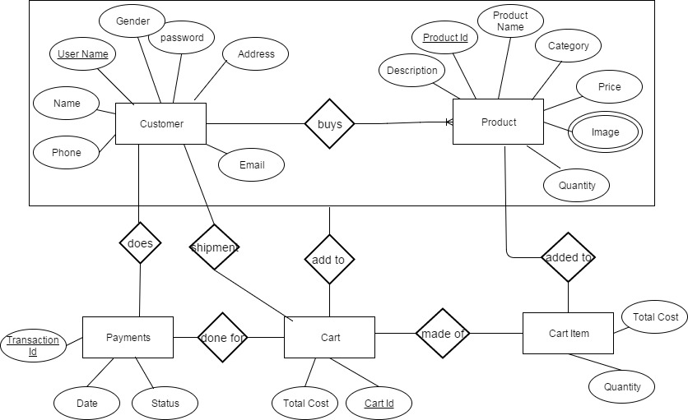

* **INFORMATION FLOW DIAGRAM OF KNECT MOBLE ACCESSORIES:-**

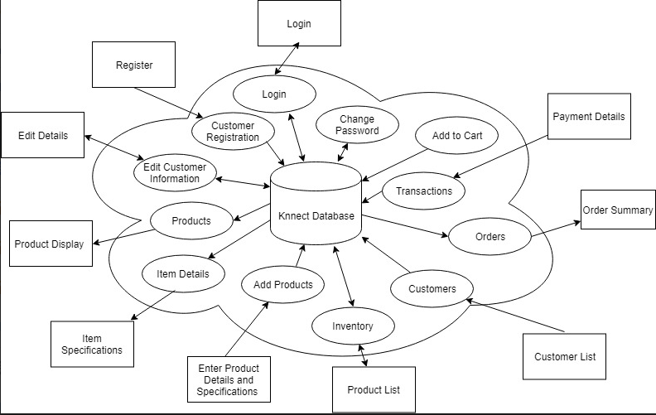

* **SITE MAP OF OUR PROJECT :-**

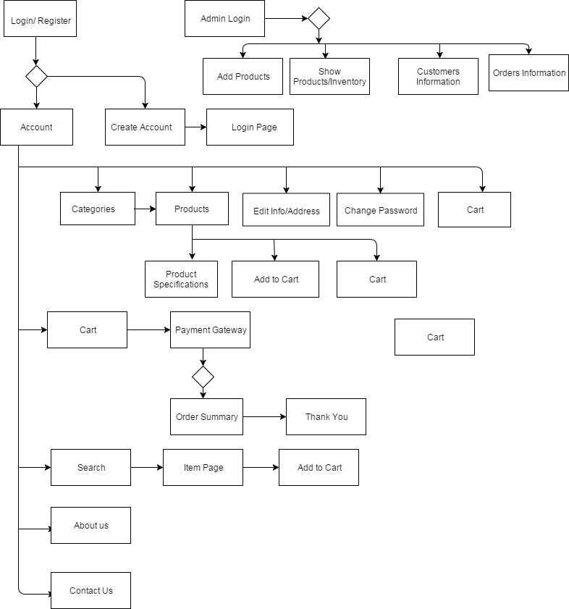

**System Design:-**

System design is the solution for the creation of a new system. System design has two phases of development:-

* Logical Design
* Physical Design

During logical design phase the analyst describes inputs (sources), outputs (destinations), databases (data sores) and procedures (data flows) all in a format that meets the user requirements. The analyst also specifies the needs of the user at a level that virtually determines the information flow in and out of the system and the data resources. Here the logical design is done through information flow diagrams and ER diagram.

The physical design is followed by physical design or coding. Physical design produces the working system by defining the design specifications, which specify exactly what the candidate system must do. The programmers write the necessary programs that accept input from the user, perform necessary processing on accepted data and produce the required report on a hard copy or display it on the screen. Here we try our best to implement it.

In this chapter we will discuss a variety of different diagrams such as information flow diagram, site map and entity-relationship diagram, which are relevant to the development phase of this web site. These diagrams explain this application flow and its logical construction very well. These diagrams are part of background research during development phase. They helped us to develop connection between different modules of the application, which is very helpful for any development.

**Implementation:-**

The system structure design is completed in the overall design phase. This phase is divided into modules, and provides the function of each module and the links between them. After this phase, according to the viewpoint of the software development, the project will step into the detailed design phase, i.e. the system implementation. The fundamental goal of this stage is to determine how to achieve the required system, and give an internal process description of each module. This chapter will give a presentation of the sub-modules of the system implementation.

Customers can purchase items on different pages, and these items are ultimately collected into the same shopping cart. Therefore the system needs a shopping cart class for the customer’s shopping process, in order to avoid unnecessary duplication of code writing, which is convenient to the maintenance and function expansion. When the user clicks on the "Purchase" button in the shopping page, the product ID is imported to the class. The product is determined by the item ID.

Websites are more sophisticated than ever. Nowadays it is not enough if a website has a great look and feel. It has to be easy to use and must present exactly the information that users want to see. In addition, users want websites to present the information in a specific way based on their individual preferences. Furthermore, users want to be able to customize the website’s user interface to fit their requirements, in order to the information they need for their demand as soon as they are logged in. Therefore, user profiles have become more important in web development.

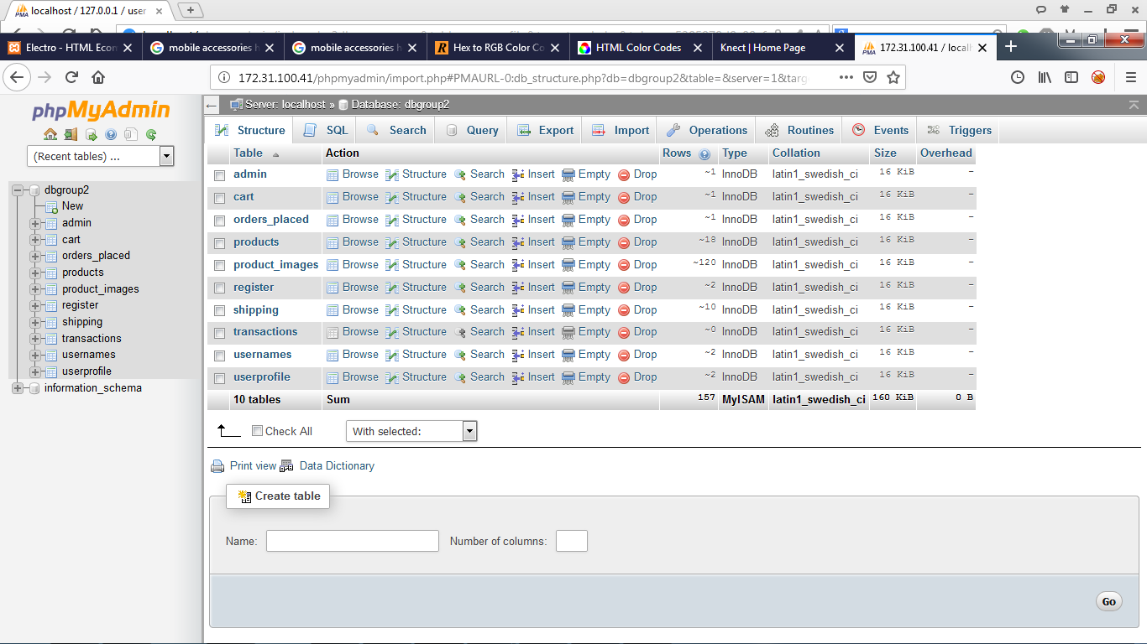**Screenshots of Databases**:-

**“products” table structure and some items:-**

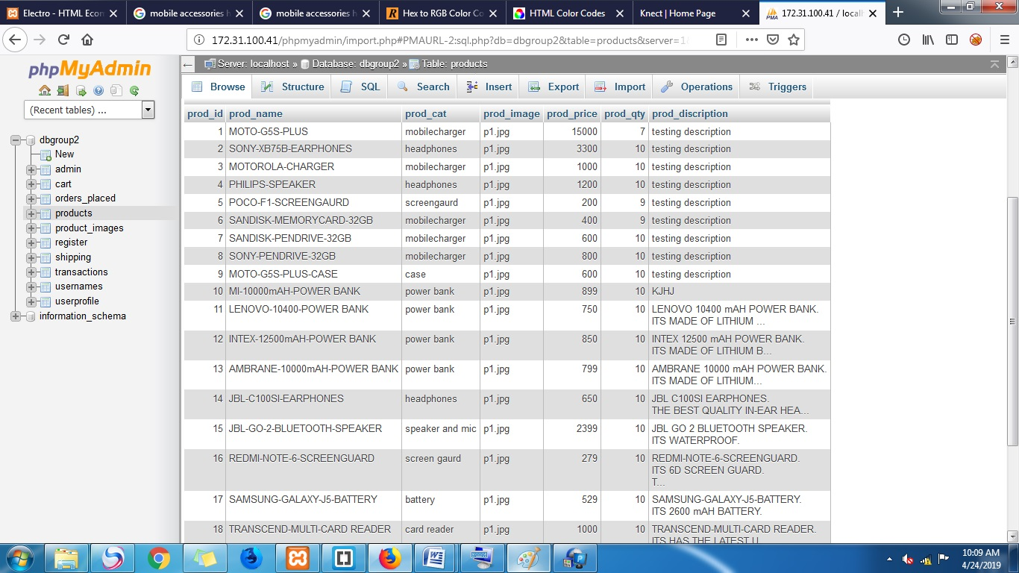

**“usernames” table structure and some items:-**

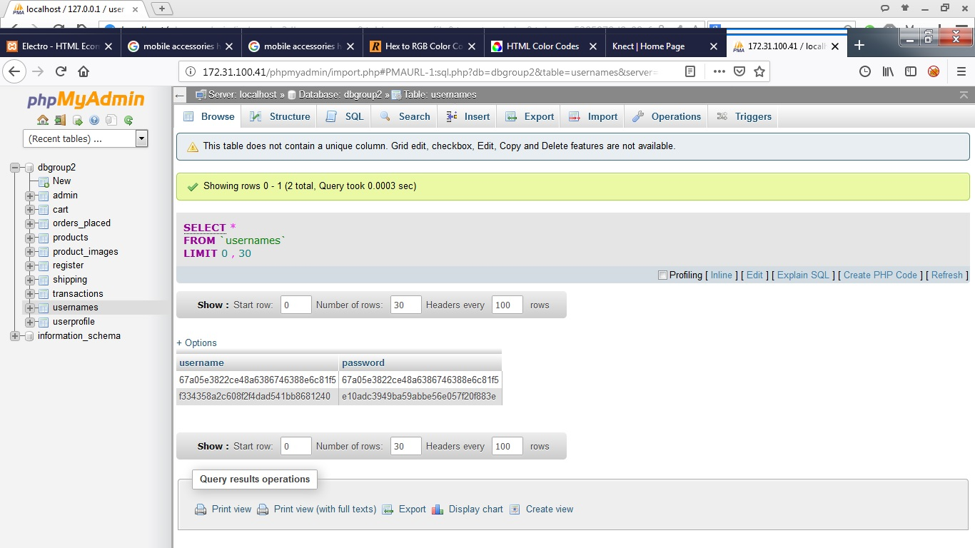

**Screenshots of Our Project:**

* **Main Landing Page:-**

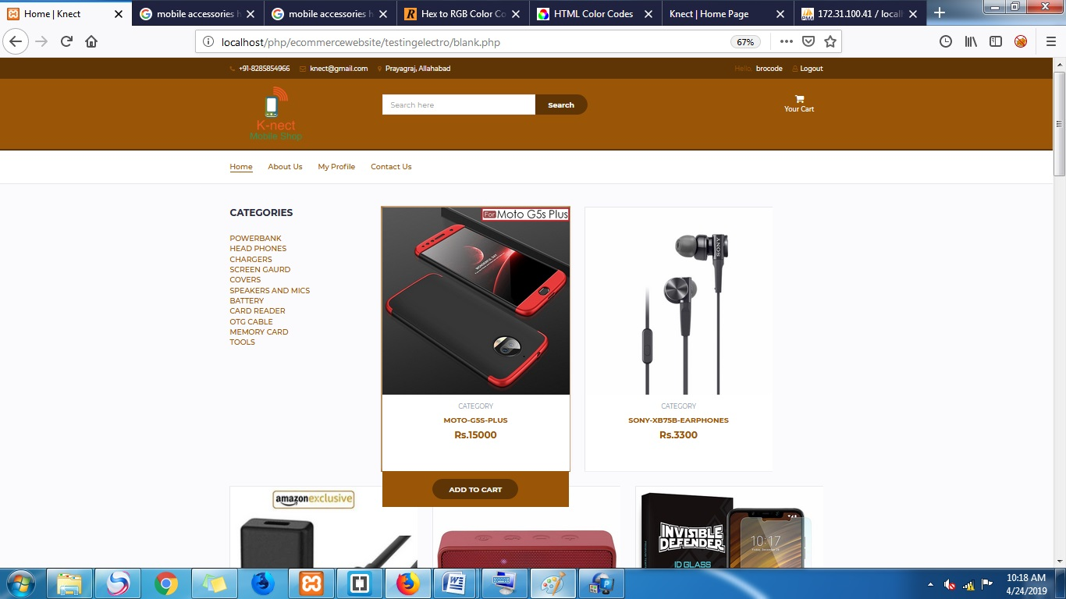

* **Screenshots of product description:-**

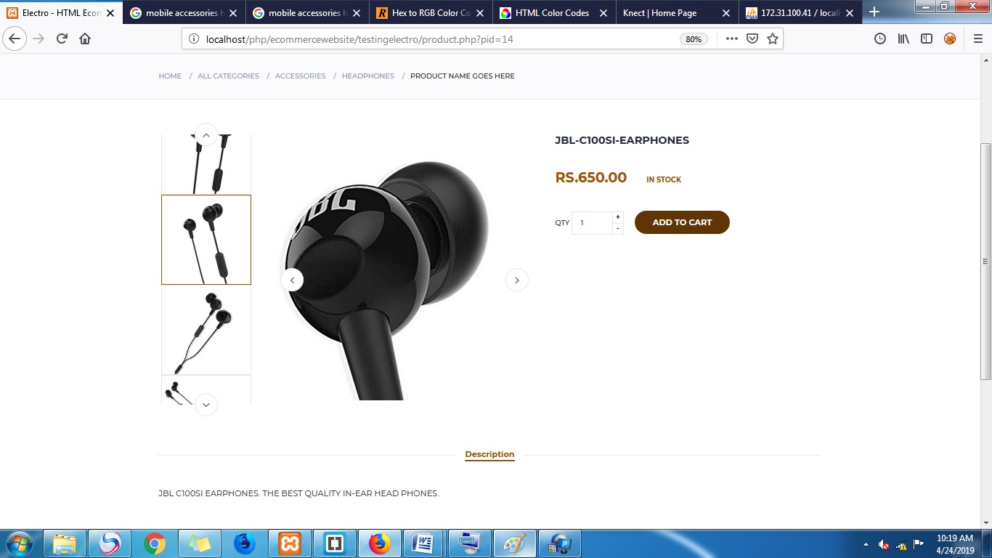

* **Screenshots of Your Cart:-**

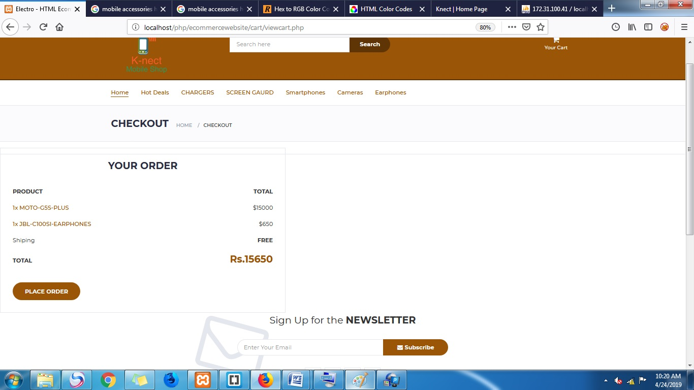**Limitation:-**

The Knect Online Mobile Accessories Store has some flows and limitation due to different requirements and time constrain. This project provides only the basic functionalities of e commerce. Several of it limitation is:

* There may be chances of security breaches and sql injection as we are still in process of studying them and methods to prevent them. We tried our best to save the customer’s data.
* To save passwords stored in the database, we have stored its hash value. So, the administrator will also not know about the password. But still there are chances of security breaches with the help of rainbow tables.
* We assume that user has prior knowledge about the interface and computer.
* This project lacks validation of forms at various places.
* Currently only one item’s information can be entered in the system at a time.

**Future Scope:-**

* This system can be implemented at Nitish’s brother mobile accessories store. The system recommends a facility to accept the orders 24*7 and a home delivery system which can make customers happy. If shops are providing an online portal where their customers can enjoy easy shopping from anywhere, the shops won’t be losing any more customers to the trending online shops such as flipkart or eBay. Since the application is a web service. it is easily accessible and always available.
* Implementation of block chain technology for increasing transparency and secure transactions.
* Implementation of Load Balancing Technologies.
* Implementation of salt pruning.
* Analyzing and updating security threats.

**Conclusion:-**

During this project, we have studied different procedures and processes involved in e commerce and presented a mobile accessories online store with the help of that study. It gives us insight to understand various concepts like supply chain management, entity resource planning, and customer relation modules as we worked on this project.

This also helps us to understand various security risks and points where data breaches can happen. We were new to the technologies like PHP, XAMPP. This project gives us a chance to learn and work on them. The application Mobile Store Management System is created to help small businesses to transfer their records from paper-based system to computerized system, even with a low budget. The requirements of a basic store have been taken care of, and a few features that can make the application easier to use and easy to understand to the user with beginner level knowledge of computers have been added.

This project helped us in gaining valuable information and practical knowledge on several topics like designing web pages using html &CSS, usage of responsive templates, designing of android applications, and management of database using MySQL . The entire system is secured. Also the project helped us understanding about the development phases of a project and software development life cycle. We learned how to test different features of a project. This project has given us great satisfaction in having designed an application which can be implemented to any nearby shops or branded shops selling various kinds of products by simple modifications. There is a scope for further development in our project to a great extent.

**Appendices- i**

* **Audit Report of FashionHUB(Group No:3) Project-**
* Look and feel of website is simple and user friendly. Load time is less.
* In this project, all pages are desktop application based. It is not support for mobile application.
* Customers can easily search and navigate any product.
* Customers can easily reach in cart section is very quickly and easy to do transaction from bank also.
* Contact us pages are very effectively, where customers can contact with admin in case of product defect, or any kind of issues.
* After registration they are verify user first time with activation code, that’s a very good features in this.

**Appendices- ii**

* **Efforts in Hacking to spoil project Ondoor(Group No: 1) -**
* We try to run java scripts. In contact as we are able to enter the message.
* We are able to edit product item with negative values.
* While ordering, if there are zero products in the cart, it will go to bank section.
* Successful to make account with false login.
* We are unable to edit our details/
* While ordering some products, some time not redirecting in orders details after did transaction.
* Limitation in address details and we can run script languages in address field. Due to while address will reflect users.



**THANK YOU!**